Create parcels from existing AutoCAD objects
- Open drawing Parcel-1A_I.dwgParcel-1A_M.dwg
- This drawing contains an existing ground surface, alignments that represent intersecting road centerlines, and AutoCAD lines and arcs that represent property boundaries. In the following steps, you will create AutoCAD Civil 3D parcel objects from the existing lines and arcs.
- Click Home tabCreate Design panelParcel drop-downCreate Parcel From Object .
- Select the lines and the polyline border at the east side of the site, north of the First Street alignment. Press Enter.
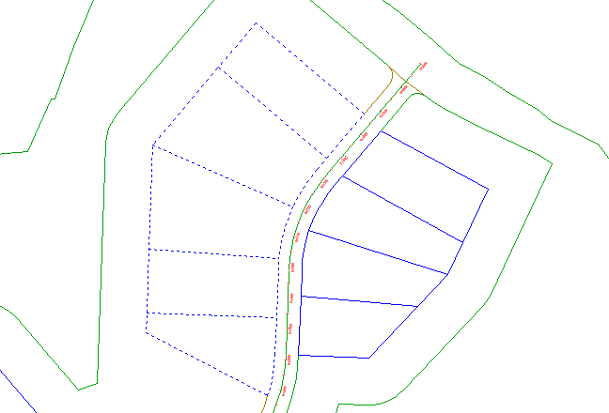
NoteOn the command line, notice that a variety of AutoCAD objects can be used to create parcels.
- In the Create Parcels – From Objects dialog box, specify the following parameters:
  - Site: Site 1
  - Parcel Style: Single-Family
  - Area Label Style: Parcel Number And Area
NoteParcels must have area labels, but segment labels are optional.
  - Automatically Add Segment Labels: Selected
  - Erase Existing Entities: Selected
- Click OK.
The parcels are created and labeled. The labels annotate the overall parcel area, as well as the bearing and distance of each line and curve segment. These labels are automatically updated if any line or curve segments are edited or deleted.
The numbers with a circular border are automatically generated parcel numbers. You will change these numbers to use a more desirable numbering convention.
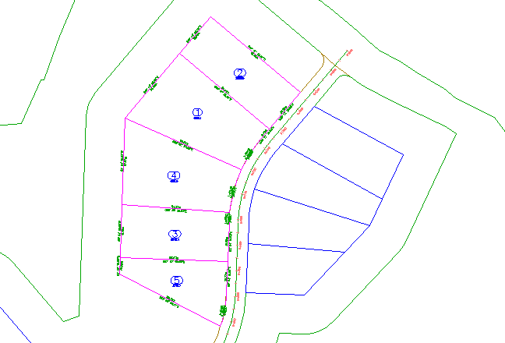
Change the parcel numbering
- Click a parcel number to select it. Click Parcel tabModify panelRenumber/Rename .
- In the Renumber/Rename Parcels dialog box, specify the following parameters:
  - Renumber: Selected
  - Starting Number: 101
  - Increment Value: 1
- Click OK.
- To specify a start point, click to top-most parcel.
- To specify an end point, click the bottom-most parcel.
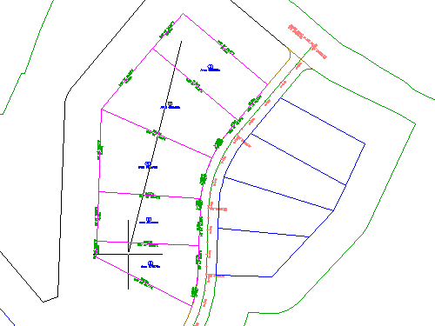
- Press Enter twice.
The parcel area labels are now numbered in ascending order, with three digits.
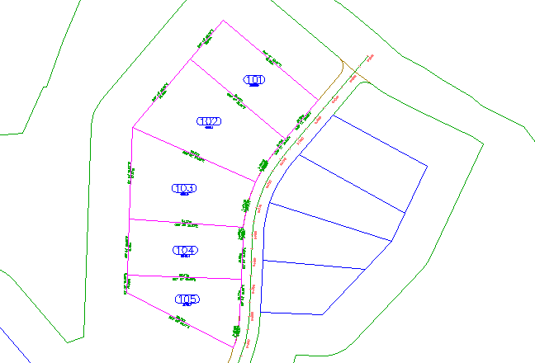

Create parcels using a free-form line
- Open Parcel-1B.dwg.
- Click Home tabCreate Design panelParcel drop-downParcel Creation Tools .
- On the Parcel Layout Tools toolbar, click Free Form Create.
- In the Create Parcels - Layout dialog box, click OK.
- In the drawing, snap to the endpoint shown in the following image.
Notice that frontage does not need to be specified.
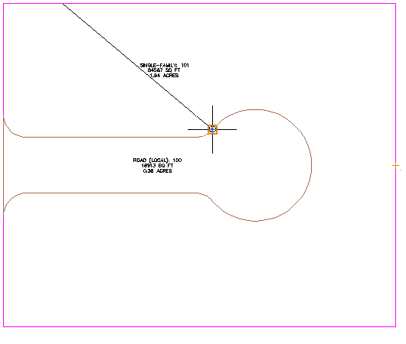
- To specify the lot line direction, move the cursor straight up, and snap to the intersection of the back lot line.
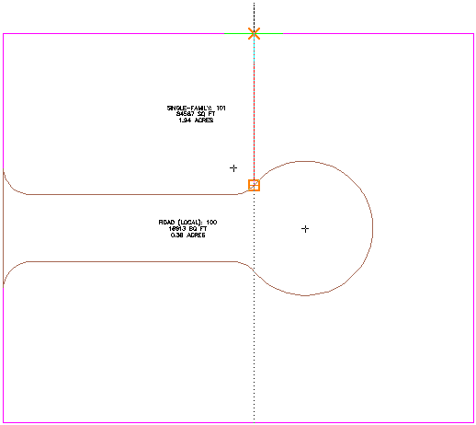
The new parcel is created and labeled.
- Repeat Steps 5 and 6 to create another lot line as shown in the following image.
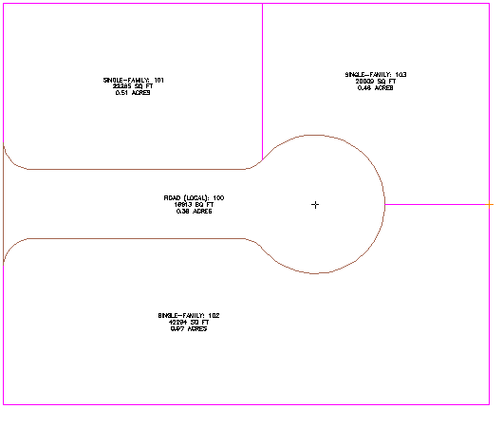
- Press Esc to end the command.

Specify parcel creation settings
- Open Parcel-1C.dwg.
- Click Home tabCreate Design panelParcel drop-downParcel Creation Tools .
- On the Parcel Layout Tools toolbar, click .
- Specify the following parameters:
As you specify each parameter, notice that a preview graphic is displayed at the bottom of the Parcel Layout Tools window.
Parcel Sizing
  - Minimum Area: 7000.00
  - Minimum Frontage: 40.0000
  - Use Minimum Frontage At Offset: Yes
  - Frontage Offset: 20.0000
  - Minimum Width: 40.0000
  - Minimum Depth: 50.0000
  - Use Maximum Depth: Yes
  - Maximum Depth: 200.0000
  - Multiple Solution Preference: Use Smallest Area
Automatic Layout
  - Automatic Mode: Off
  - Remainder Distribution: Place Remainder In Last Parcel
NoteWhen Automatic Mode is set to Off, the Remainder Distribution setting does not affect parcel layout. This setting will be used in later exercises.
Create individual parcels using a slide line
- In the Parcel Layout Tools toolbar, click Slide Line – Create.
- In the Create Parcels – Layout dialog box, for Parcel Style, select Single-Family. Leave other settings at their default values. Click OK.
- Click the area label for parcel Single-Family: 101.
- Specify the start and end points of the parcel frontage as shown in the following image.
Notice that when you move the cursor to specify the end point, a yellow line displays the proposed frontage.
NoteWhen you specify the frontage starting point, do not snap to the beginning of the curve. If the frontage starts at the beginning point of the curve, no solution will be found.
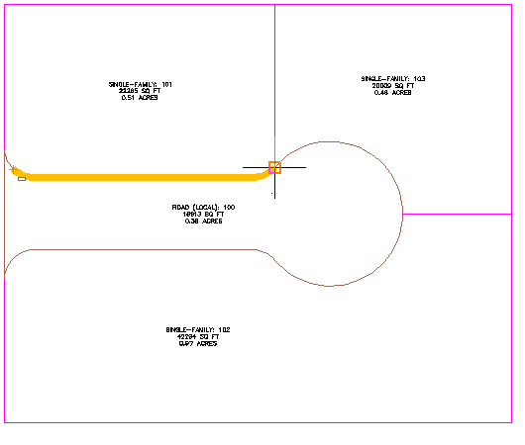
- Enter a frontage angle of 90 degrees.
Preview graphics of the parcel creation parameters and proposed solution are displayed. The graphics are similar to those that were displayed while you were specifying parcel creation parameters in the Parcel Layout Tools window.
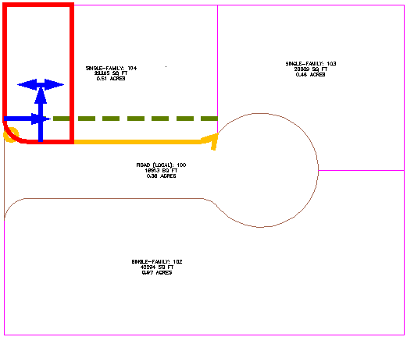
- Press Enter.
The new parcel is created and labeled, and a preview of the next parcel is displayed in the drawing.
- In the Parcel Layout Tools dialog box, for Minimum Area, enter 8000.
Notice that the preview graphic updates to reflect the changed area value.
- Press Enter.
Two new parcels are created and labeled.
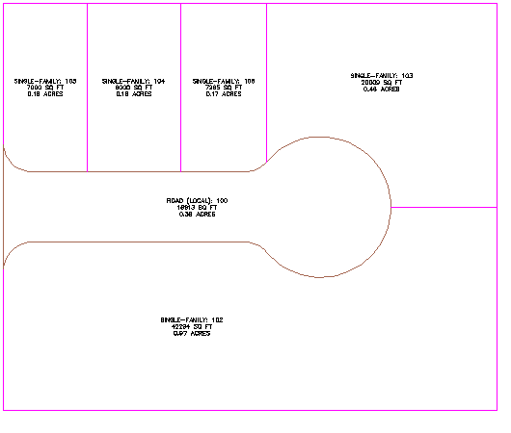
Create multiple parcels simultaneously
- In the Parcel Layout Tools toolbar, click Slide Line – Create.
- Under Automatic Layout, specify the following parameters:
  - Automatic Mode: On
  - Remainder Distribution: Place Remainder In Last Parcel
- Click the area label for the large parcel on the south side of the site.
- Specify the start and end points of the parcel frontage as shown in the following image.
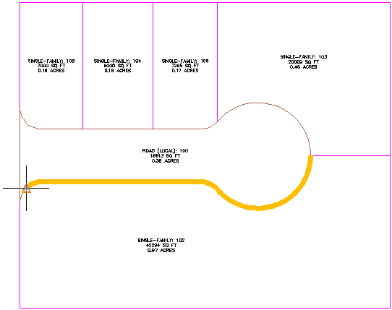
- Enter a frontage angle of 90 degrees.
A preview of the proposed parcels is displayed.
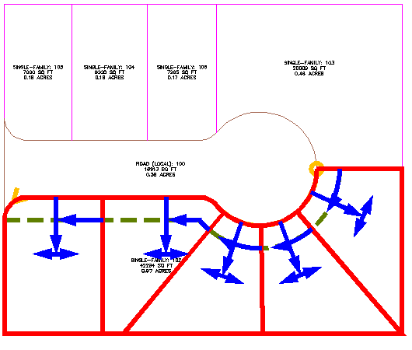
- Press Enter.
The new parcels are created and labeled.
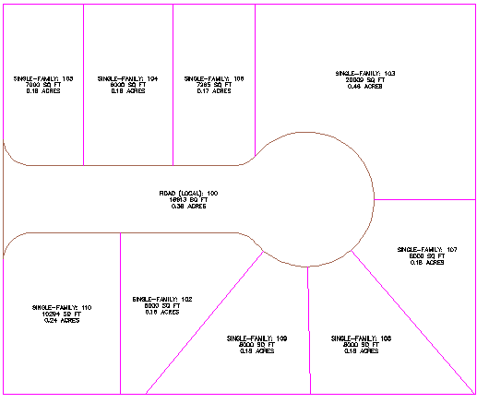
- Press Esc to end the command.

